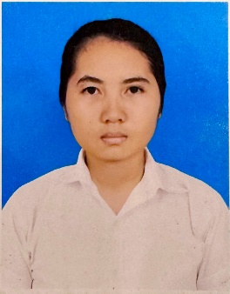CURRICULUM VITAE

Name : TIT PUM

Address : St. Asain11 Sangkat Tektla, Khan Sensok, Phnom Penh

Email : [titsreychen@gmail.com](mailto:titsreychen@gmail.com)

Tel : 070 618 505

**PERSONAL INFORMATION**

Name : TIT PUM

Date of Birth : 16, March, 1999

Sex : Female

Place of birth : Bavet City, Svay Rieng Province

Nationality : Khmer

Marital Status : Single

Health : Good

**EDUCATION**

2012-2014 : Study at Chiphu high school

2014-2016 : Study at Chiphu high school

2016-2020 : I have graduated with a bachelor’s degree at RUPP with majoring Information Technology (IT).

**WORK EXPERENCE**

2019-2021 : Work as Cashier at Café Amazon Cambodia

2022-2023 : Work as accountant at Sheico Cambodia Co., LTD

**COMPUTER AND ENGLISH EDUCATIONAL BACKGROUND**

I have learned HTML, CSS, PHP, SQL, and Bootstrap. Also, I did an assignment related to Web Design in year 4.

**OTHER INTERESTS**

Like Communication with people and Self-development

Interest in working in detail and track keeping

**LANGUAGES**

Khmer : Mother Tongue

English : Reading, Listening and Speaking

**REFERENCE**

Team Leader

Mrs. Sam Sinath

Email: sinath_sam@Sheico.kh